Hacker Rank Test AI – Backend Developer

1. Trip Query

A travel and tour company has two tables relating to customers: FAMILIES and COUNTRIES. Each tour offers a discount if a minimum number of people book at the same time.

Write a query to print the maximum number of discounted tours any one family in the FAMILIES table can choose from.

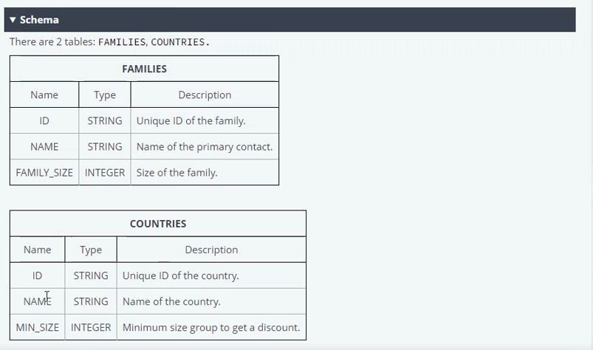

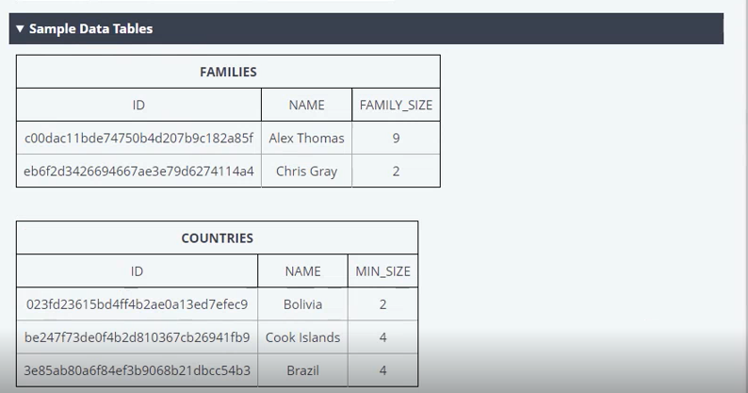

Sample output:

3

Explanation:

The Thomas Family can choose from any of the tours and qualify for the discount. The Gray family only qualifies for 1.

MAX for 3 and 1 is 3.

JAWABAN = SELECT

1. Parking Dilemma

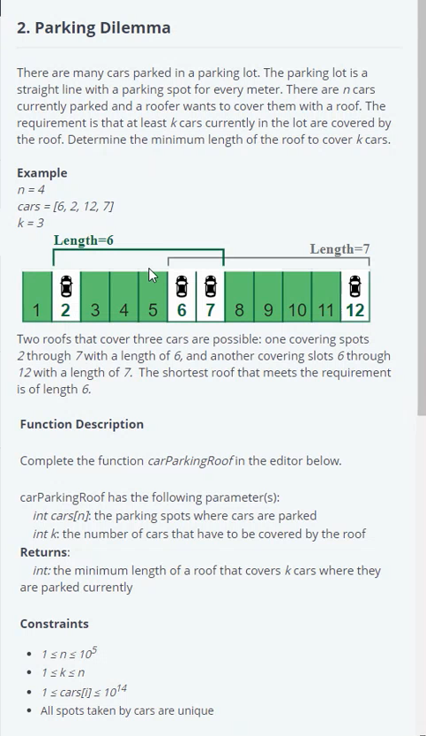

list = [2 6 7 12] 7 - 2 + 1 = 6 12 - 6 + 1 = 7 k = 3 min = 99999999

for i in range(0, len(list)-k):

temp = list[k-1 + i] - list[i] + 1

if temp < min:

min = temp print(min)

1. .Net Core Room Service Authorization

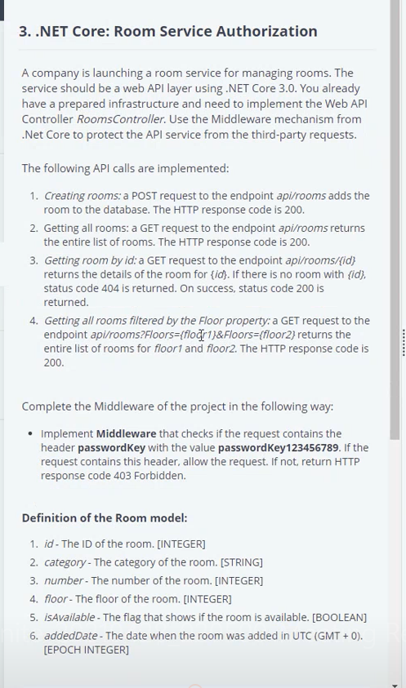

1. Multiple choice

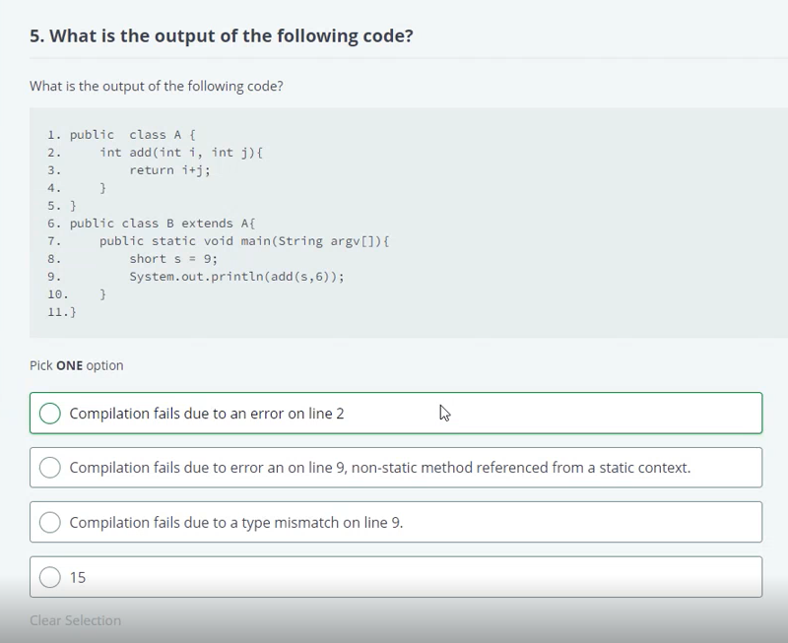

Jawaban : B

1. Divide two numbers

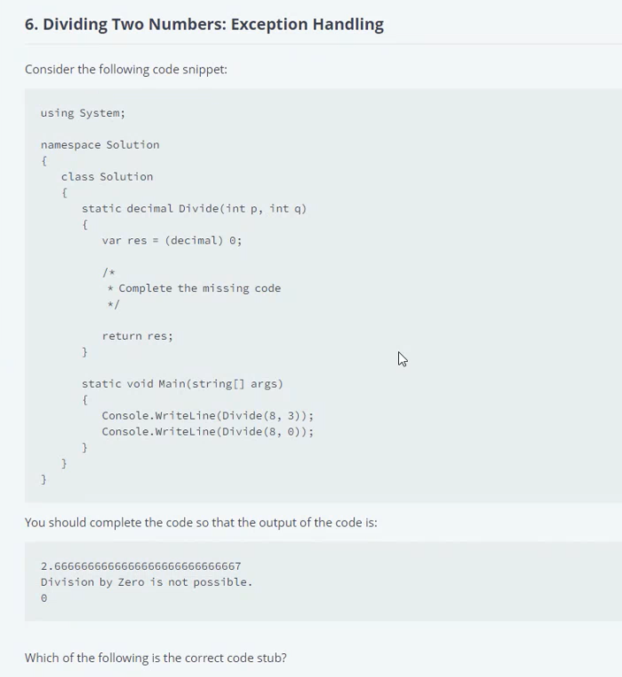

if (q == 0 ){

sout"Division by zero is imposibble"

} else {

res = p/q

}

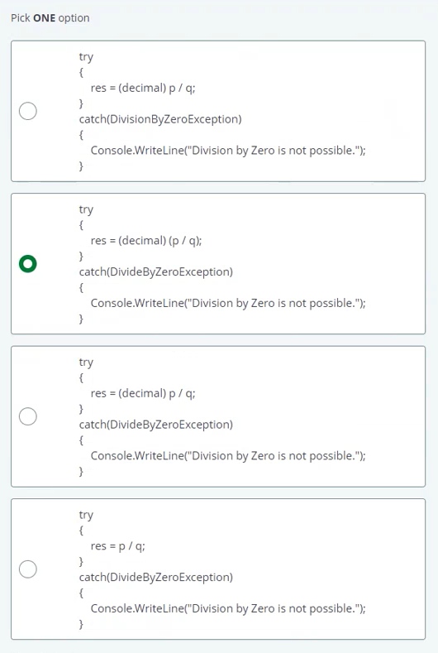

Jawaban : C

1. Most Active Authors

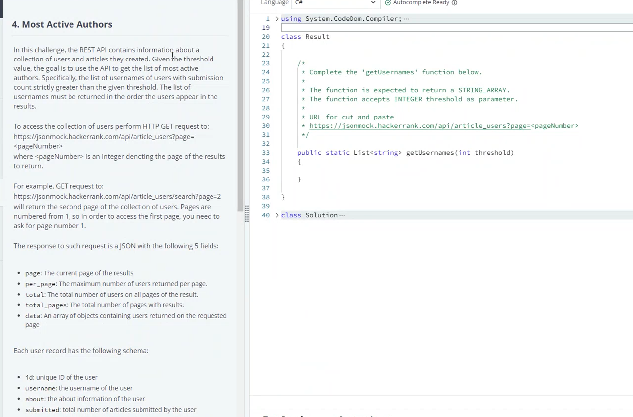

1. Least Earning Location

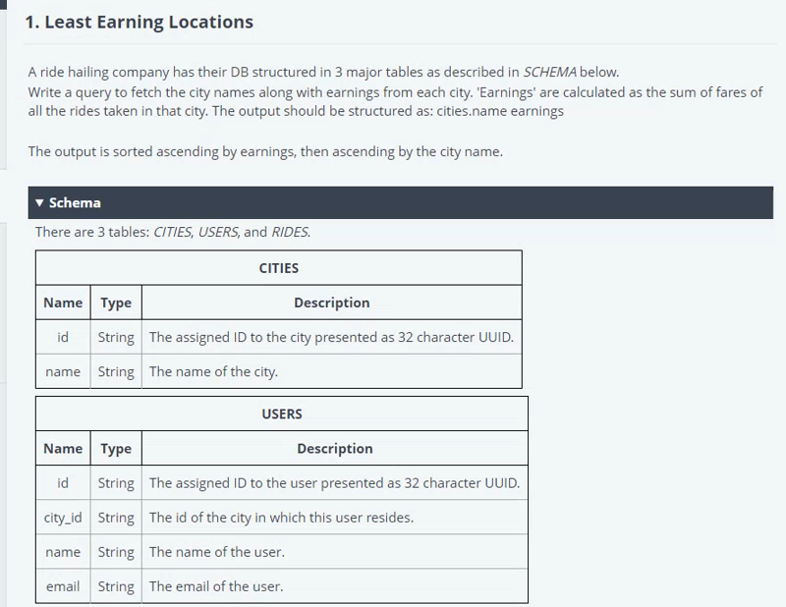

1. .NET Core Car Cache

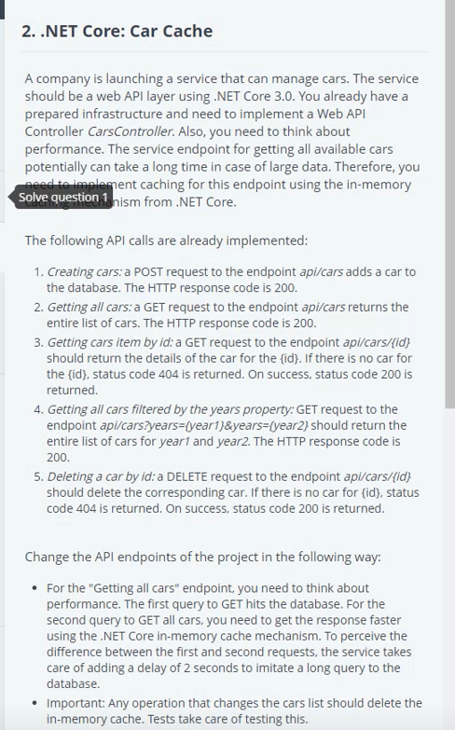

1. Sport Inheritance

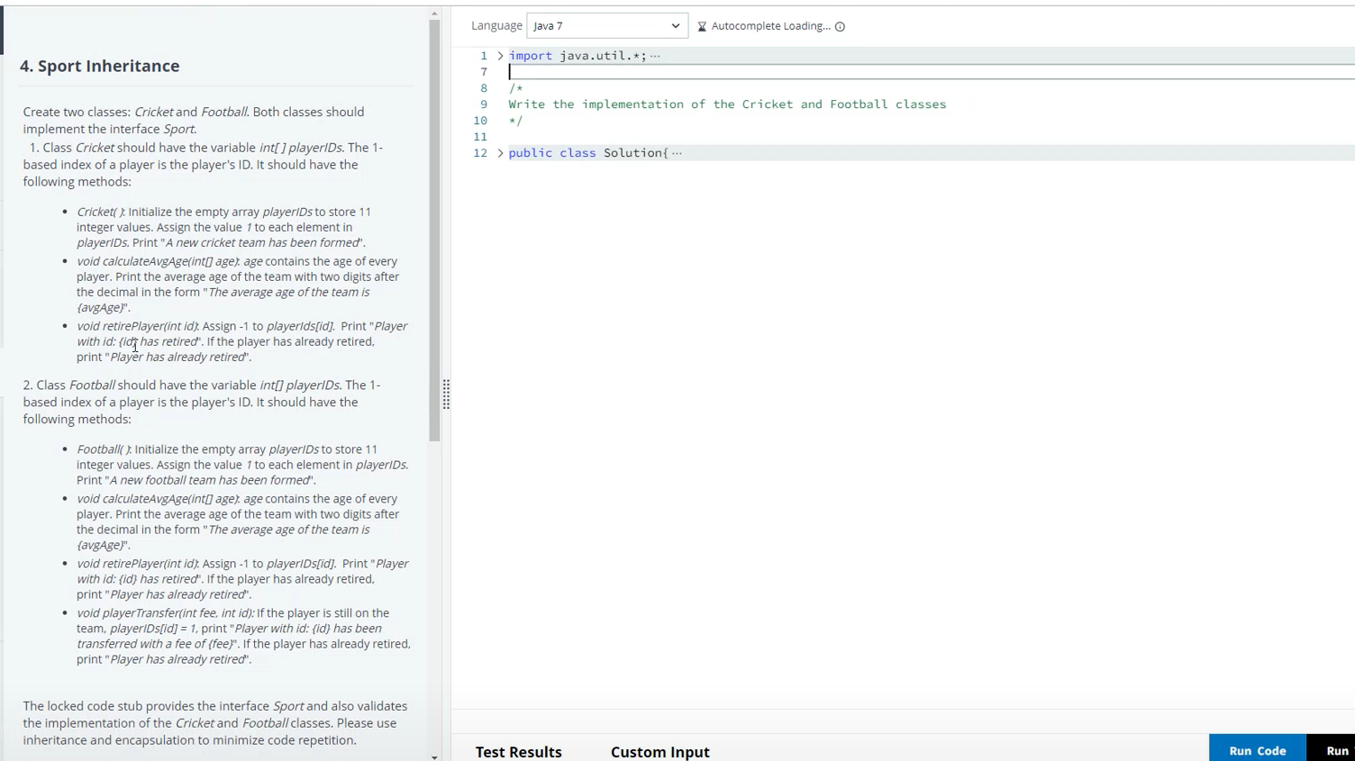

1. Garbage Collection

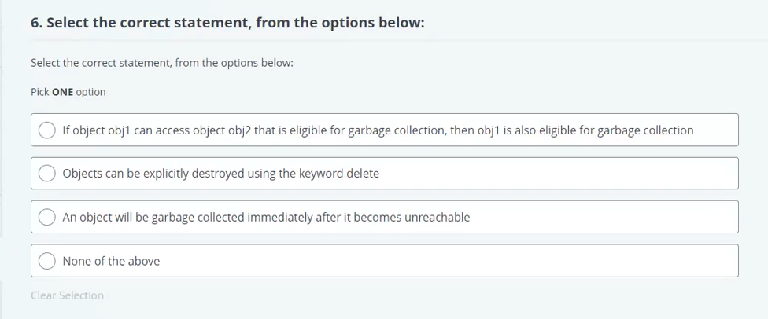

1. Thread Safe

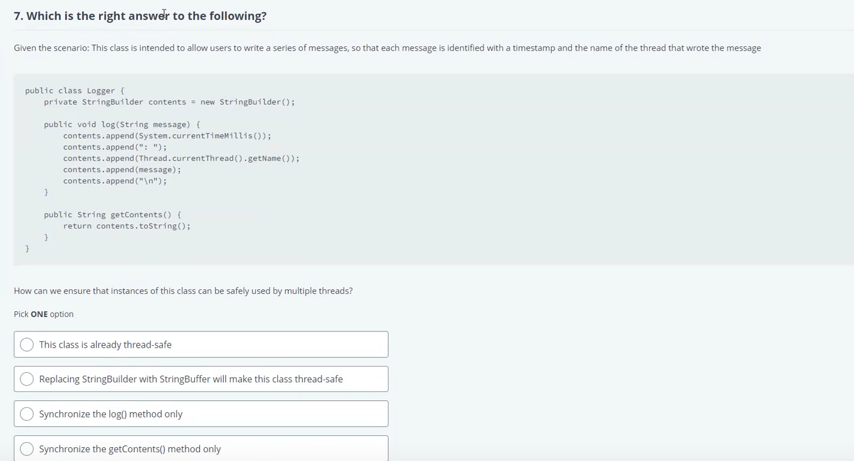

1. Java Program

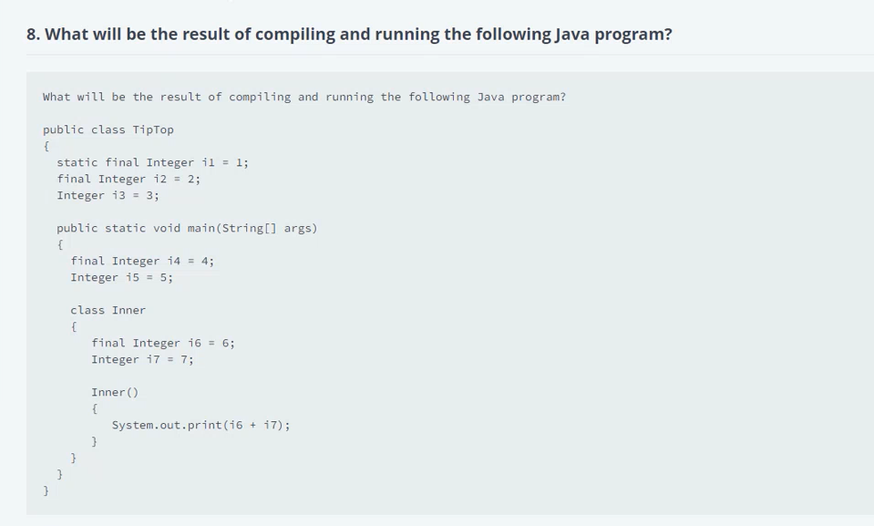

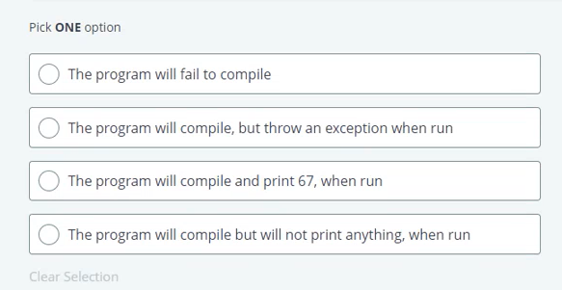

Jawaban: D (class Inner() tidak dipanggil.

1. Java Design Patterns

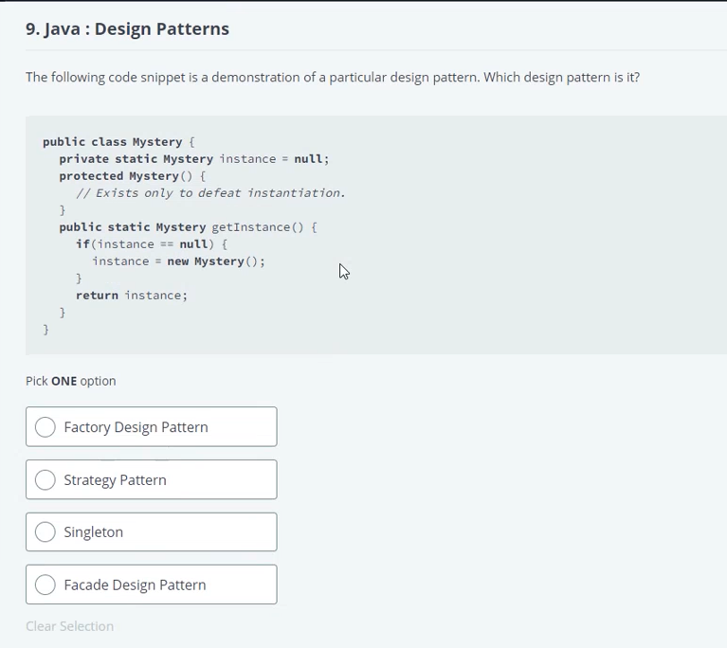

Singleton